Part A- Understanding One-Person Company Systems:
One-Person company concept:
one-person company is a business that is run by one person who is responsible for all decisions and tasks. Instead of having employees, the Founder uses digital tools and systems to manage the work.
These digital systems can support the business by handling tasks like managing money, communicating with customers, organizing work, and promoting services. Also, intelligent agents can be used, where each agent helps in a specific task and gives suggestions to the Founder.
So, with the help of technology, one person can successfully manage a complete business in an easier and more efficient way.

Architecture of a One-Person Company:
A one-person company is structured in a simple way where one person manages the whole business with the help of digital systems.
- Founder/owner is the main decision maker. They control the business and choose the final actions based on the information they receive.
- digital agents are software programs that help the Founder by handling specific tasks. Each agent has a role, such as managing money, marketing, or customer support.
- business tasks include daily activities like processing orders, answering customers, tracking expenses, and planning work.
- system components are the main parts of the system, such as the Founder, agents, tasks, and data. These components work together to make the system organized and efficient.

Role of Multi-Agent Systems:
Multi-agent systems help the Founder by using several digital agents, where each agent is responsible for a specific task. Instead of one system doing everything, the work is divided between different agents.
Each agent focuses on one responsibility, such as finance, marketing, or customer support. This makes the work faster and more organized.
The agents can also provide suggestions and information to help the Founder make better decisions. This reduces the workload on the Founder and allows them to manage the business more efficiently.
In simple terms, multi-agent systems make it possible for one person to handle multiple responsibilities with the help of smart digital assistants.

Programming Perspective:
This system can be modeled using Object-Oriented Programming by representing each part of the system as a class.
For example, the Founder, agents, and tasks can all be created as classes. Each class has its own attributes and functions. The Founder class can manage tasks, while the Agent classes can process tasks and provide recommendations.
OOP also allows the use of concepts like inheritance and encapsulation, which help organize the system and make it easier to manage and update.
By using OOP, the system becomes more structured, reusable, and easier to understand.

Part B- – Business Idea and Project Proposal:
- Business name: IT support system
- Business background:
It’s a smart IT support system helps users solve their technical problems easily.
The system provides support for common issues such as slow devices, internet problems, and software errors.
The goal is to give quick and simple solutions without needing a large support team.
- Target Customers
The target customers are:
- Students.
- Employees.
- Anyone facing technical problems.
- People who need quick IT support.
- Why This Business Can Be Managed by One Person:
This business can be managed by one person because digital agents handle most of the work.
Each agent is responsible for a specific task, such as diagnosing problems or suggesting solutions.
The Founder only reviews the results and makes the final decision.
- Proposed Agents:
  - Diagnosis Agent

Identifies the type of technical problem (hardware, software, or network).

  - Solution Agent

Provides possible solutions based on the problem.

  - Ticket Agent

Records and manages user requests and assigns ticket numbers.

- Example Interaction:
User:
My laptop is very slow.
Diagnosis Agent:
The problem is related to system performance.
Solution Agent:
You should delete unnecessary files and restart the device.
Ticket Agent:
Your request has been recorded with ID #101.
Founder:
Approved, send solution to the user.

Part C- System Planning and Design:
    - System Architecture:
The system starts when a user submits a technical problem. The Founder receives the request and creates a task in the system.
The task is then sent to different digital agents. First, the Diagnosis Agent analyzes the problem and identifies its type. Then, the Solution Agent provides possible solutions based on the diagnosis. The Ticket Agent records the request and assigns a ticket number.
After that, all results are sent back to the Founder, who reviews the recommendations and makes the final decision. Finally, the solution is delivered to the user. solution is delivered to the user.

    - Multi-Agent Structure:
- Diagnosis Agent
- Responsibilities: Identify the type of the problem
- Tasks handled: Problem analysis
- Information processed: User input and error description
- Solution Agent
- Responsibilities: Provide solutions
- Tasks handled: Suggesting fixes
- Information processed: Problem type and system knowledge
- Ticket Agent
- Responsibilities: Manage requests
- Tasks handled: Creating and tracking tickets
- Information processed: User data and request details

    - System Classes:
The system is designed using the following main classes:
- Company: Represents the whole system
- Founder: Controls the system and makes final decisions
- Agent: Base class for all agents
- DiagnosisAgent, SolutionAgent, TicketAgent: Derived from Agent
- Task: Represents a user request
- Memory: Stores previous tasks and results
- KnowledgeBase: Stores solutions and information
- Report/Recommendation: Contains the results provided by agents

    - UML Class Diagram
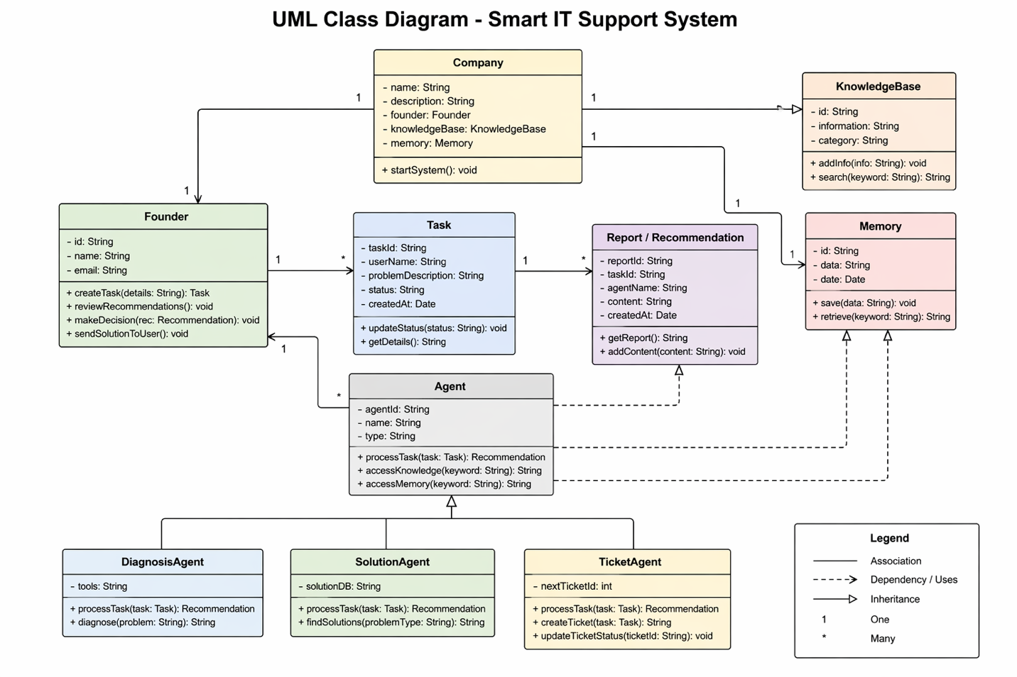

Part D – System Implementation:
Links:
Colab link https://colab.research.google.com/drive/1N7mgOK74YkfPn2uSjIyP-pDgNVJB5SJ0
Github link https://github.com/fatmaali224/it-support-system

